Syeda Reeha Quasar

14114802719

4C7

Topics Covered

AWT Components Event Handling

Lab - 9

Java Programming Lab

# **EXPERIMENT – 9.1**

## **Aim:**

WAP that illustrates how to process mouse click, enter, exit, press and release events. The background color changes when the mouse is entered, clicked, pressed, released or exited.

## **Theory:**

**Class :** A class is a group of objects which have common properties. It is a template or blueprint from which objects are created. It is a logical entity. It can't be physical. It represents the set of properties or methods that are common to all objects of one type. A class in java has its methods, variables.

**Java MouseListener Interface :** The Java MouseListener is notified whenever you change the state of mouse. It is notified against MouseEvent. The MouseListener interface is found in java.awt.event package. It has five methods.

**Methods of MouseListener interface**

The signature of 5 methods found in MouseListener interface are given below:

1. public abstract void mouseClicked(MouseEvent e);
2. public abstract void mouseEntered(MouseEvent e);
3. public abstract void mouseExited(MouseEvent e);
4. public abstract void mousePressed(MouseEvent e);
5. public abstract void mouseReleased(MouseEvent e);

**Java Swing :** It is a part of Java Foundation Classes (JFC) that is *used to create window- based applications*. It is built on the top of AWT (Abstract Windowing Toolkit) API and entirely written in java. Unlike AWT, Java Swing provides platform-independent and lightweight components. The javax.swing package provides classes for java swing API such as JButton, JTextField, JTextArea, JRadioButton, JCheckbox, JMenu, JColorChooser etc.

**Java JFrame :** The javax.swing.JFrame class is a type of container which inherits the java.awt.Frame class. JFrame works like the main window where components like labels, buttons, textfields are added to create a GUI . Unlike Frame, JFrame has the option to hide or close the window with the help of setDefaultCloseOperation(int) method.

## **Source Code:**

package javaapplication1;

import javax.swing.JApplet;

import java.awt.event.MouseListener;

import java.awt.event.MouseEvent;

import java.awt.Color;

import javax.swing.JFrame;

import java.awt.event.ActionListener;

/**

*

* @author REEHA

*/

public class mouseEvent extends JApplet {

public void init() {}

public static void main(String[] args) {

JFrame frame = new JFrame();

final int FRAME_WIDTH = 500;

final int FRAME_HEIGHT = 600;

frame.setSize(FRAME_WIDTH, FRAME_HEIGHT);

frame.setDefaultCloseOperation(JFrame.EXIT_ON_CLOSE);

frame.setVisible(true);

class MouseEnterExitListener implements MouseListener {

public void mouseEntered(MouseEvent event) {

System.out.println("ENTER");

frame.getContentPane().setBackground(Color.BLUE);

}

public void mouseExited(MouseEvent event) {

System.out.println("EXIT");

frame.getContentPane().setBackground(Color.RED);

}

public void mouseReleased(MouseEvent event) {

System.out.println("RELEASED");

frame.getContentPane().setBackground(Color.GREEN);

}

public void mouseClicked(MouseEvent event) {

System.out.println("CLICKED");

frame.getContentPane().setBackground(Color.BLACK);

}

public void mousePressed(MouseEvent event) {

System.out.println("PRESSED");

frame.getContentPane().setBackground(Color.YELLOW);

}

}

MouseListener listener = new MouseEnterExitListener();

frame.addMouseListener(listener);

}

}

## **Output:**

Window of applet with different mouse events:

 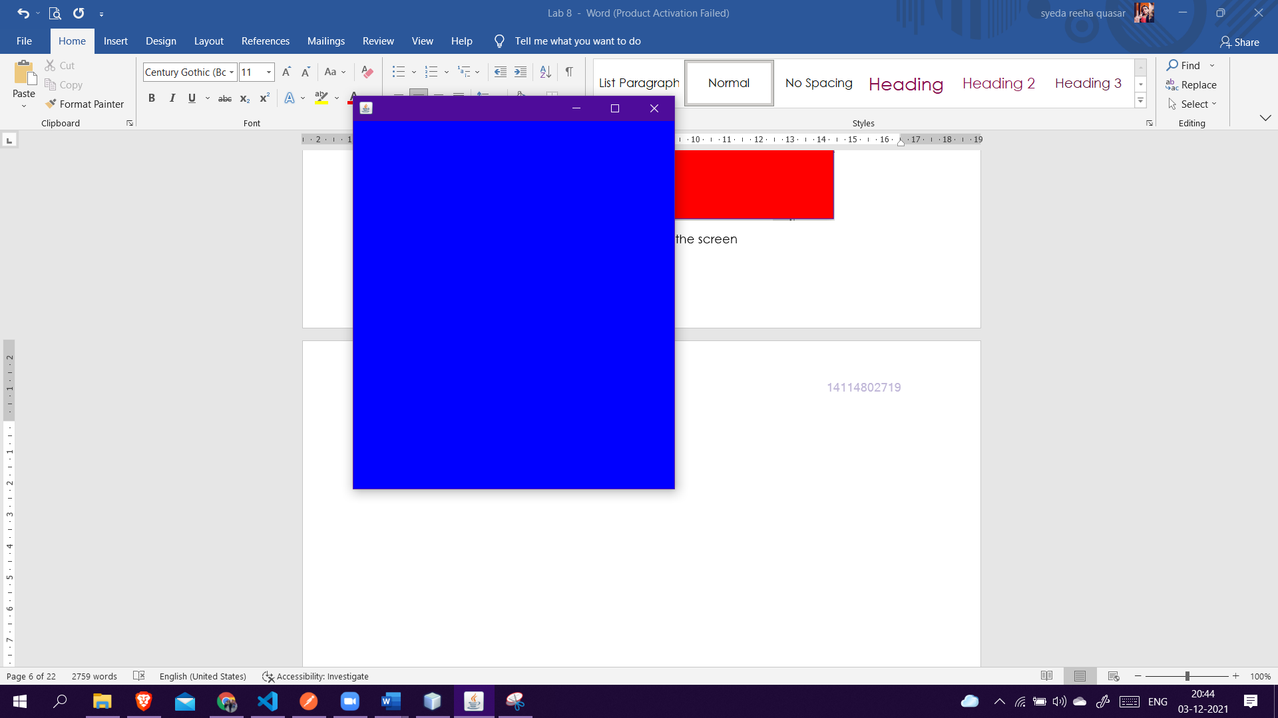

When mouse is out of the screen When mouse in the applet window

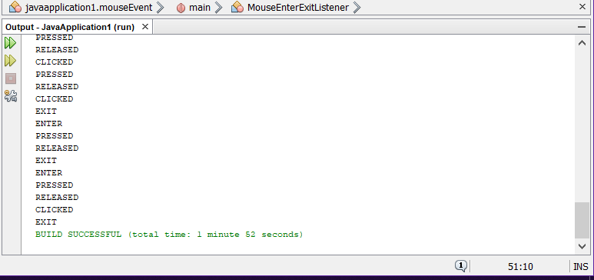

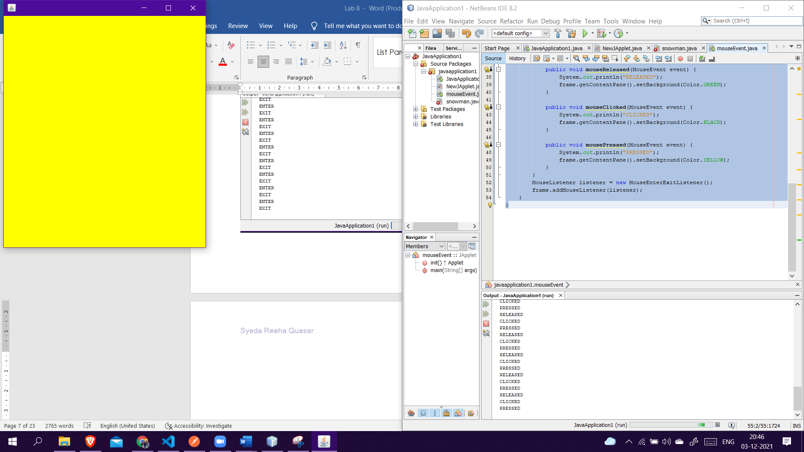 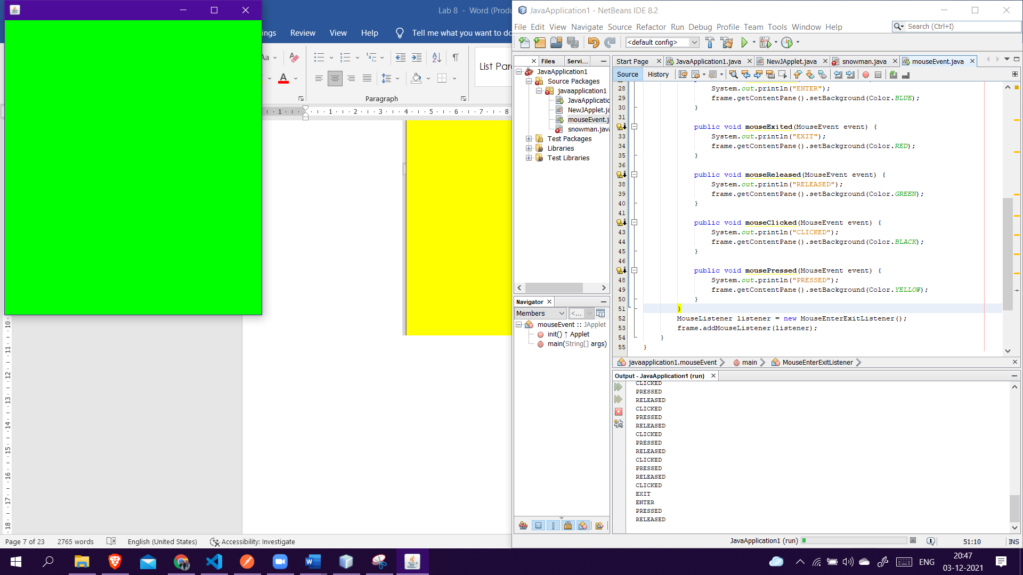

When mouse is pressed When mouse is released

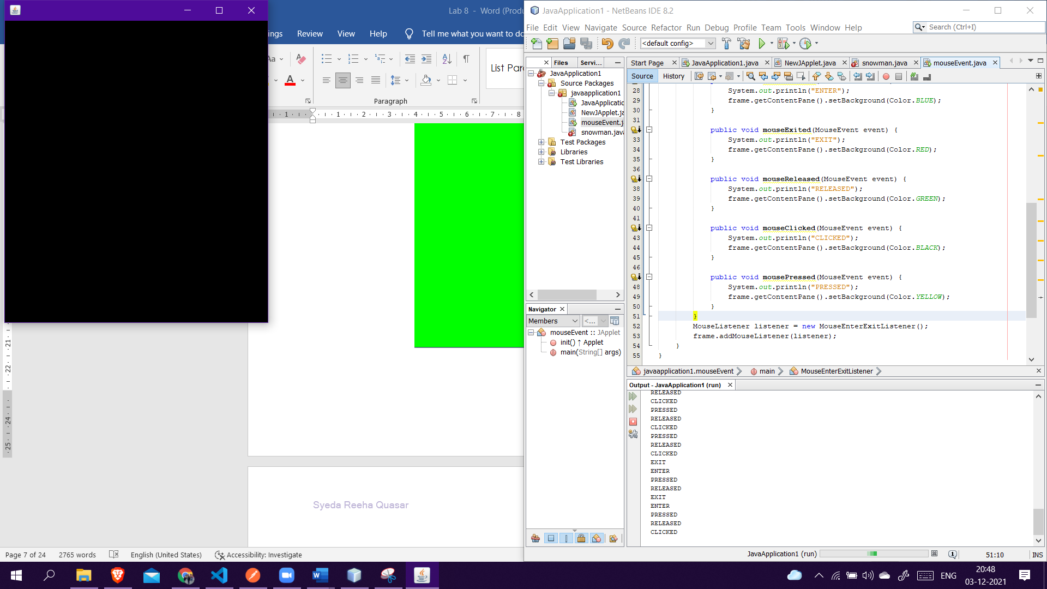

When mouse is clicked

**On Mouse Entering**

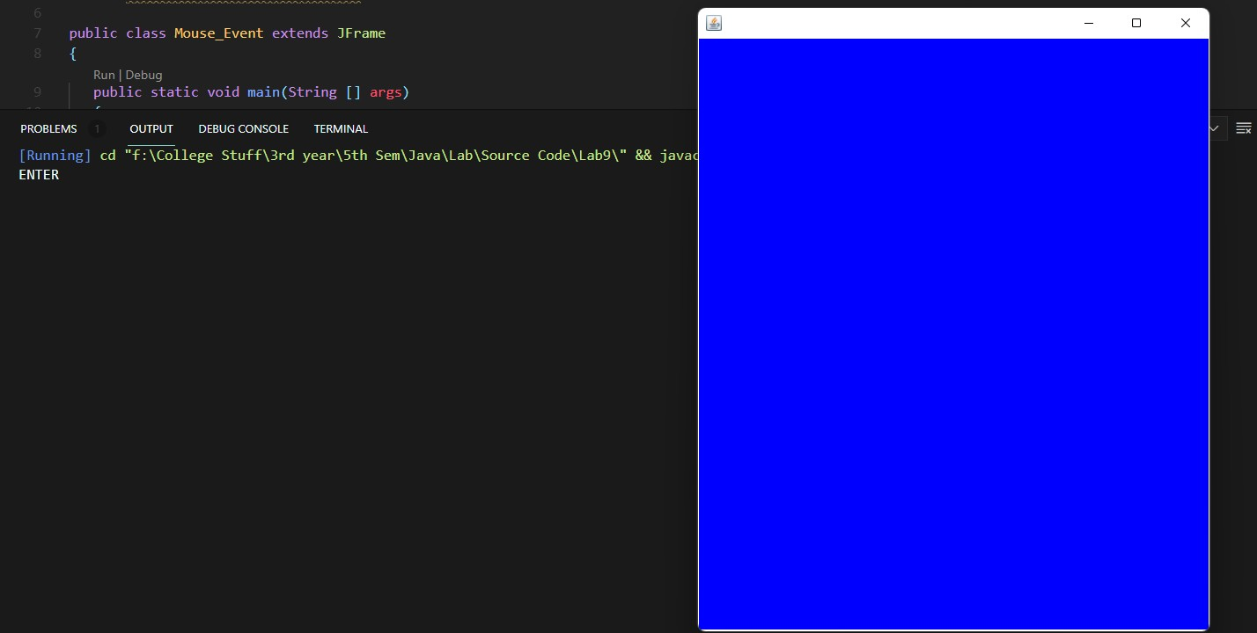

**On Mouse Exiting**

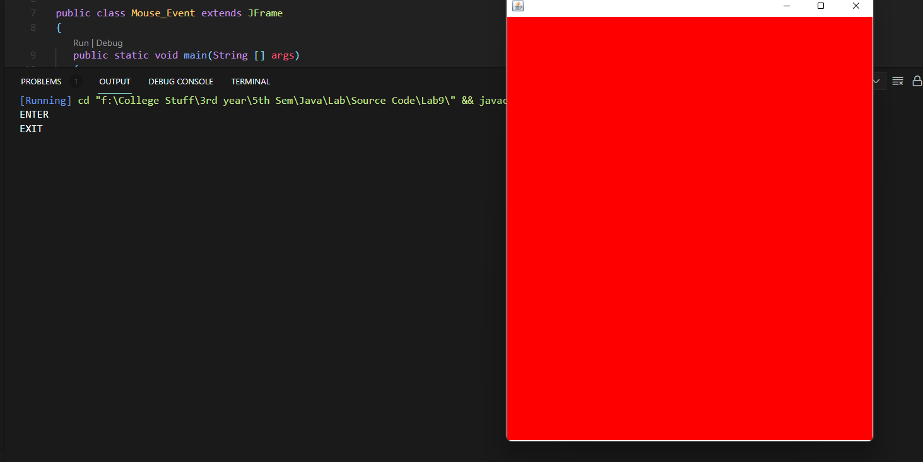

**On Mouse Press**

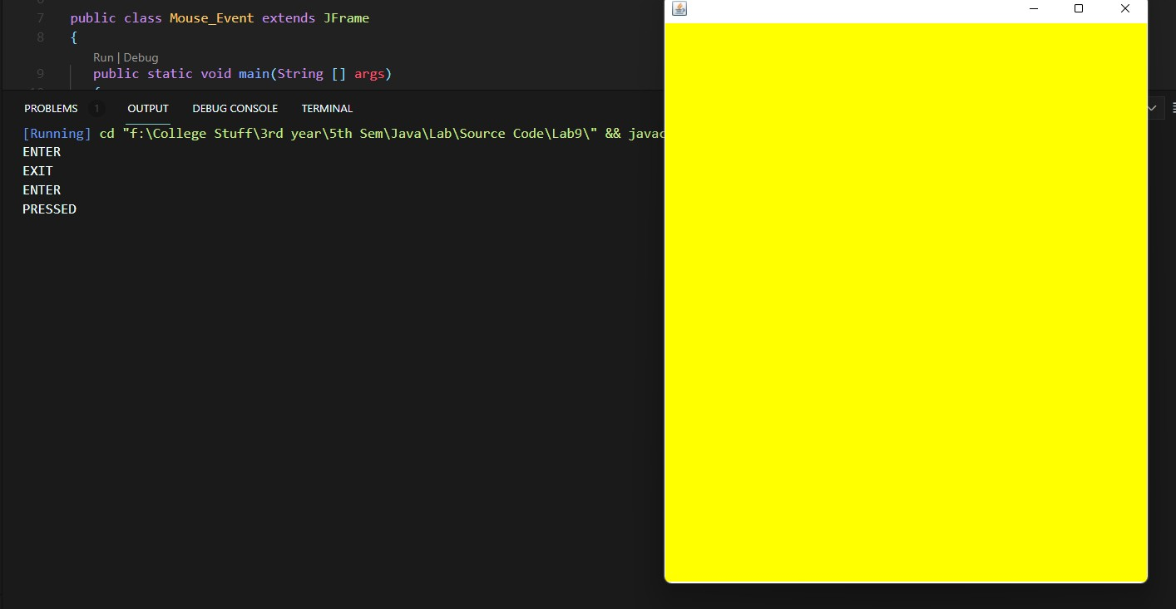

**On Mouse Click**

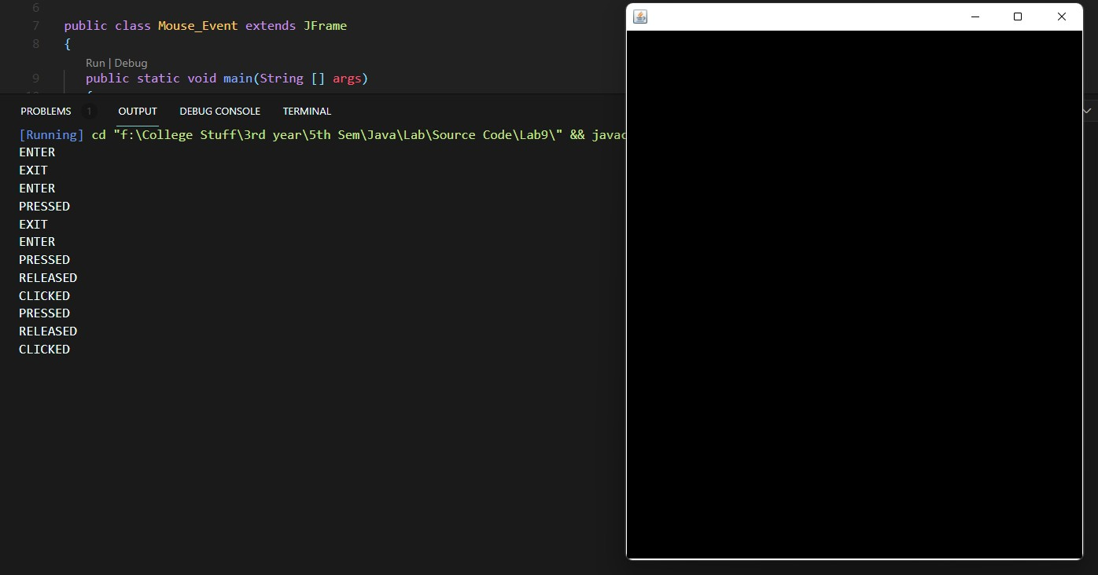

**On Mouse Release**

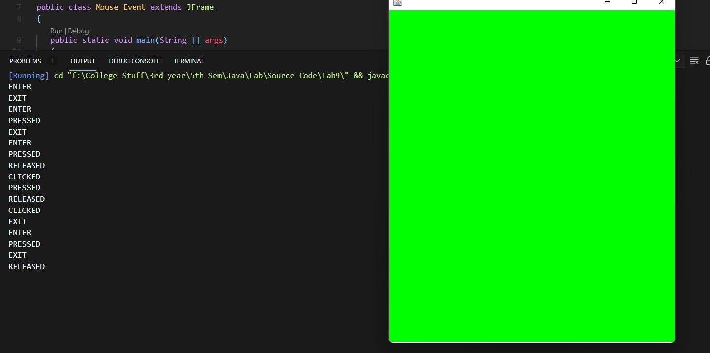

# **EXPERIMENT – 9.2**

## **Aim:**

WAP that displays your name whenever the mouse is clicked.

## **Theory:**

**Class :** A class is a group of objects which have common properties. It is a template or blueprint from which objects are created. It is a logical entity. It can't be physical. It represents the set of properties or methods that are common to all objects of one type. A class in java has its methods, variables.

**Java MouseListener Interface :** The Java MouseListener is notified whenever you change the state of mouse. It is notified against MouseEvent. The MouseListener interface is found in java.awt.event package. It has five methods.

**Methods of MouseListener interface**

The signature of 5 methods found in MouseListener interface are given below:

1. public abstract void mouseClicked(MouseEvent e);
2. public abstract void mouseEntered(MouseEvent e);
3. public abstract void mouseExited(MouseEvent e);
4. public abstract void mousePressed(MouseEvent e);
5. public abstract void mouseReleased(MouseEvent e);

**Java Swing :** It is a part of Java Foundation Classes (JFC) that is *used to create window- based applications*. It is built on the top of AWT (Abstract Windowing Toolkit) API and entirely written in java. Unlike AWT, Java Swing provides platform-independent and lightweight components. The javax.swing package provides classes for java swing API such as JButton, JTextField, JTextArea, JRadioButton, JCheckbox, JMenu, JColorChooser etc.

**Java JFrame :** The javax.swing.JFrame class is a type of container which inherits the java.awt.Frame class. JFrame works like the main window where components like labels, buttons, textfields are added to create a GUI . Unlike Frame, JFrame has the option to hide or close the window with the help of setDefaultCloseOperation(int) method.

## **Source Code:**

package javaapplication1;

import javax.swing.JApplet;

import javax.swing.*;

import java.awt.*;

import java.awt.event.*;

/**

*

* @author reeha

*/

public class mouse_click implements MouseListener,ActionListener {

static JFrame frame;

static JTextField text;

public static void main(String[] args) {

frame = new JFrame("Display Name on mouse click");

frame.setBackground(Color.white);

frame.setSize(500, 500);

frame.setLayout(null);

text = new JTextField();

text.setBounds(0, 0, 500, 50);

frame.add(text);

JButton exit = new JButton("Exit");

exit.setBounds(220, 235, 60, 30);

frame.add(exit);

mouse_click obj = new mouse_click();

frame.addMouseListener(obj);

exit.addActionListener(obj);

frame.setVisible(true);

}

@Override

public void actionPerformed(ActionEvent e) {

frame.dispose();

}

@Override

public void mouseEntered(MouseEvent e) {

text.setText("");

}

@Override

public void mouseExited(MouseEvent e) {

text.setText("");

}

@Override

public void mouseReleased(MouseEvent e) {

text.setText("");

}

@Override

public void mousePressed(MouseEvent e) {

text.setText("");

}

@Override

public void mouseClicked(MouseEvent e) {

text.setText("");

text.setText("Syeda Reeha Quasar : 14114802719");

}

}

## **Output:**

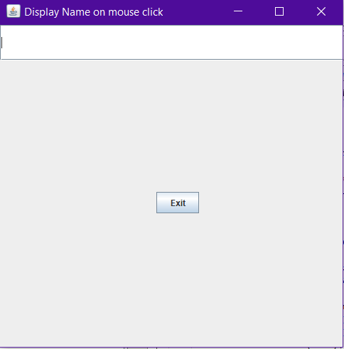

No Mouse activity

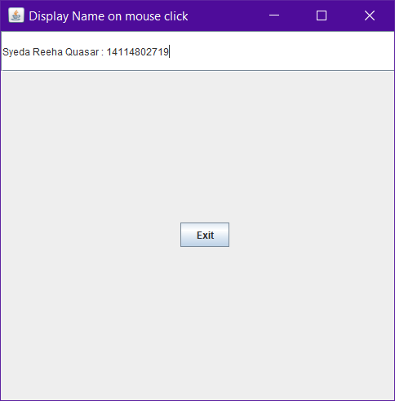

On Mouse Click

**Exits as we press exit!**

# **Viva Questions**

### **1. Difference between Swing and Awt?**

### Ans.

AWT are heavy-weight componenets. Swings are light-weight components. Hence swing works faster than AWT.

### **2. What Are The Different Types Of Controls In Awt?**

### Ans.

The AWT supports the following types of controls:

Labels, Pushbuttons, Checkboxes, Choice lists, Lists, Scroll bars, Text componentsThese controls are subclasses of component.

**3. How will you communicate between two Applets?**

### Ans.

### The simplest method is to use the static variables of a shared class since there's only one instance of the class and hence only one copy of its static variables. A slightly more reliable method relies on the fact that all the applets on a given page share the same AppletContext. We obtain this applet context as follows:

### AppletContext ac = getAppletContext();

AppletContext provides applets with methods such as getApplet(name), getApplets(),getAudioClip, getImage, showDocument and showStatus().

### **4. Which classes can an applet extend?**

Ans.

An applet can extend the java.applet.Applet class or the java.swing.JApplet class. The java.applet.Applet class extends the java.awt.Panel class and enables you to use the GUI tools in the AWT package. The java.swing.JApplet class is a subclass of java.applet.Applet that also enables you to use the Swing GUI tools.

### **5. What Are The Benefits Of Swing Over Awt?**

### Ans.

* Swing components are light weight.
* We can have a pluggable look and feel feature which shows us how they appear in other platforms.
* We can add images to Swing components. We have toolbars and tooltips in Swing.